History Day

History Day: Breaking Barriers in History

Topic | Date | Self-Evaluation |  |  |  | Points | Teacher Sign Off
Library Topic Digs |  | 1 | 2 | 3 | 4
Understanding the Theme |  | 1 | 2 | 3 | 4
Narrowing & Choosing your Topic |  | 1 | 2 | 3 | 4
Finding Sources |  | 1 | 2 | 3 | 4
Historical Context |  | 1 | 2 | 3 | 4
Research Questions |  | 1 | 2 | 3 | 4
Project Map |  | 1 | 2 | 3 | 4
Sources |  | 1 | 2 | 3 | 4
Mid Construction Check |  | 1 | 2 | 3 | 4
Final Construction Self Reflection |  | 1 | 2 | 3 | 4
School Showcase |  | 1 | 2 | 3 | 4
Parent Showcase |  | 1 | 2 | 3 | 4

Preparation:
What overall grade (percentage or letter) am I hoping to achieve in this unit? _______
- I did all that I could to achieve my goal in preparing for this unit.
- I can make the following adjustments to increase my grade for this and future units.
  - ________________________________________________________________________
  - ________________________________________________________________________
  - ________________________________________________________________________

Self-Evaluation:
- I was not on task or engaged and therefore I cannot do this with help, I need a review lesson
- I was mostly not on task or engaged but I can do this with help. There are parts I do not understand.
- I was on mostly task and engaged, and I can do this independently, I understand.
- I was on task, engaged and I am an expert and can teach it to others.

This packet was created as a collaboration from resources found on NHD.org and MN History Day

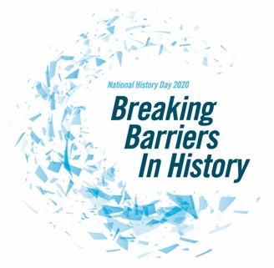
Breaking Barriers in History

Understanding the History Day Theme

- Write the definition in your own words for each of the theme words in the boxes below.

Barrier
Alliance
Impact

- Breaking Barriers in Real Life: Think about how the ideas of action, challenge, supporting, achieving, or change are a part of your life.
Barrier
Alliance
Resistance
Change
Impact

Selecting a Topic

Topic Brainstorm
A good way to choose a topic is to start with a general area of history you find interesting. This might be something you read about in a class or something related to family history. Using the chart below brainstorm one topic in each category that fits this year’s theme, Breaking Barriers in History
Politics |  | The Environment
Topic Idea |  | Topic Idea
Nevada |  | Social Movements
Topic Idea |  | Topic Idea
Military History |  | Religion
Topic Idea |  | Topic Idea
Science & Technology |  | Education
Topic Idea |  | Topic Idea
Continents in Conflict |  | Arts, Music, & Culture
Topic Idea |  | Topic Idea
Health |  | Literature & Media
Topic Idea |  | Topic Idea

The Topic Narrowing Funnel
Using the funnels below, try narrowing down two of your general interests into more focused topics

